WEEK 3 PROJECT REPORT

State Management
and React Hooks
Mini Application: Task Manager

Prepared as a Week 3 React internship deliverable
Technology: React • JavaScript • Context API • Hooks • localStorage

1. Project Overview
The Week 3 project is a task-management mini-application built with React. It demonstrates component-based UI development, state management with React Hooks, shared state through the Context API, a reusable custom hook, and persistence using browser localStorage.

Objectives
- Use useState to manage form input and the selected task filter/search state.
- Use useEffect to persist task changes to localStorage.
- Create a custom useTasks hook to centralize task operations and persistence.
- Use Context API to make task state and actions available to nested components.
- Use useMemo to derive filtered task results from tasks, filter selection, and search text.
- Provide common task-management interactions: add, complete, delete, filter, search, and clear completed tasks.

2. Application Features
- Add tasks: Users can enter a task title and add it to the task list. Empty or whitespace-only titles are rejected, and surrounding whitespace is trimmed.
- Complete and reactivate tasks: A task can be toggled between completed and active states.
- Delete tasks: A task can be removed from the list.
- Filter tasks: All, Active, and Completed filters show the corresponding subset.
- Search: The search input filters tasks by title without regard to letter case.
- Clear completed: The user can remove all completed tasks in one action.
- Persistent storage: Task state is saved to localStorage and loaded again when the page is revisited or refreshed, when browser storage is available.
- Responsive layout: The page styling includes responsive rules so the interface can adapt to narrower screens.

3. Technology Stack
- React and React DOM for the component-based user interface.
- JavaScript with JSX for application logic and UI markup.
- Webpack and Babel for development serving, bundling, and JSX/JavaScript transformation.
- CSS for layout, responsive presentation, focus states, and component styling.
- ESLint for static code-quality checks.
- Browser localStorage for client-side persistence.

4. Architecture and File Structure
The application separates task logic, shared state, UI components, and styling. This makes the code easier to understand, test, and extend.
src/
├── App.jsx
├── index.jsx
├── context/
│ └── TaskContext.jsx
├── hooks/
│ └── useTasks.js
├── components/
│ └── tasks/
│ ├── TaskForm.jsx
│ ├── TaskList.jsx
│ └── TaskFilters.jsx
└── styles/
├── main.css
└── components.css

Component responsibilities
- App.jsx — Wraps the dashboard in TaskProvider and coordinates search/filter state. It uses useMemo to calculate the visible task list.
- TaskContext.jsx — Creates the task context, supplies task state and actions through TaskProvider, and exposes useTaskContext for consumers.
- useTasks.js — Owns the tasks state and operations: addTask, toggleTask, deleteTask, clearCompleted. It reads and writes localStorage.
- TaskForm.jsx — Controls the new-task input with useState and submits validated task titles.
- TaskFilters.jsx — Displays task counts, filter buttons, and the clear-completed action.
- TaskList.jsx — Renders the currently visible task list and provides controls for toggling and deleting tasks.

5. State Management
State is divided by responsibility. The task collection and task actions are managed by the custom hook and exposed through Context. Local UI state remains close to the component that needs it.

Local component state
- TaskForm uses useState to store the current input value. After a valid submission, the form clears the input.
- TaskDashboard uses useState for the active filter ('all', 'active', or 'completed') and search text.

Shared task state
TaskProvider calls useTasks and publishes the returned task list and action functions. Components use useTaskContext to access the shared values without passing task state through every intermediate component.

Derived state
The visible list is derived from the task collection, selected filter, and search query. useMemo recalculates this list when one of those dependencies changes; the filtered list is not stored as a second independent state.

6. Hooks Used
- useState: Stores changing values such as tasks, form input, selected filter, and search query.
- useEffect: Synchronizes the task collection to localStorage whenever tasks change.
- useContext: Reads the shared task manager from TaskContext.
- useMemo: Memoizes the filtered task list until tasks, filter, or search changes.
- Custom hook — useTasks: Encapsulates task state, persistence, and task actions in one reusable function.

7. Custom Hook: useTasks
The useTasks hook separates task-management logic from presentation components. It initializes tasks from localStorage using a lazy useState initializer. Parsing and storage operations are guarded with try/catch blocks so unavailable or invalid storage does not crash the app. The hook returns the task array and four action functions.

Action behavior
- addTask(title): trims the title, ignores empty input, creates a task ID and timestamp, and prepends the new task.
- toggleTask(taskId): uses a functional state update to invert the selected task's completed flag.
- deleteTask(taskId): removes the matching task using filter().
- clearCompleted(): removes completed tasks while preserving active tasks.
The useEffect dependency array contains tasks, so persistence runs after task state changes. If localStorage is unavailable, the catch block prevents a storage exception from breaking the render flow.

8. Context API Flow
- App renders TaskProvider.
- TaskProvider calls useTasks and receives tasks plus task action functions.
- TaskProvider supplies those values through TaskContext.Provider.
- TaskForm, TaskList, and TaskFilters access shared values through useTaskContext.
- A user action calls an action function, updates state, triggers a render, and useEffect persists the updated tasks.

9. Testing and Verification
The project owner reported that both `npm run lint` and `npm run build` completed successfully after resolving ESLint configuration and catch-block syntax issues. The following manual checks should be completed in the browser and evidenced with screenshots.
Test | Expected result | Status
Add task | New task appears and counts update | To confirm
Toggle completion | Completed/remaining counts update | To confirm
All / Active / Completed | Each filter shows the matching tasks | To confirm
Search | Task titles match the search query, case-insensitively | To confirm
Delete task | Selected task is removed | To confirm
Clear completed | Completed tasks are removed | To confirm
Refresh persistence | Previously saved tasks remain after refresh | To confirm
ESLint | npm run lint completes without errors or warnings | Reported successful
Production build | npm run build completes successfully | Reported successful

10. Screenshot Evidence
Insert genuine screenshots from the running application and VS Code. The placeholders below identify the recommended evidence. Do not label a test as passed unless it was performed and the result was observed.
[Insert screenshot: 01_initial_dashboard.png]
Initial dashboard showing the heading, task form, filters, search, and list/empty state.
[Insert screenshot: 02_add_tasks.png]
Three example tasks added and task counts updated.
[Insert screenshot: 03_completed_task.png]
A completed task and updated counts.
[Insert screenshot: 04_active_filter.png]
Active filter selected and only unfinished tasks visible.
[Insert screenshot: 05_completed_filter.png]
Completed filter selected and only finished tasks visible.
[Insert screenshot: 06_search_tasks.png]
Search query and matching task results.
[Insert screenshot: 07_delete_task.png]
Task list after deleting one task.
[Insert screenshot: 08_clear_completed.png]
List after clearing completed tasks.
[Insert screenshot: 09_persistence_after_refresh.png]
A saved task still visible after refreshing the browser.
[Insert screenshot: 10_custom_hook.png]
useTasks.js showing state, persistence, and task operations.
[Insert screenshot: 11_context_api.png]
TaskContext.jsx showing provider and context hook.
[Insert screenshot: 12_state_management.png]
App.jsx showing state and filtered-task calculation.
[Insert screenshot: 13_task_form.png]
TaskForm.jsx showing controlled input and submission handler.
[Insert screenshot: 14_production_build.png]
Terminal output for successful npm run build.
[Insert screenshot: 15_lint_check.png]
Terminal output for successful npm run lint.

11. Running the Application
- Open the project folder in VS Code.
- Install dependencies if needed by running `npm install`.
- Start the development server with `npm run start`.
- Open the local address shown in the terminal (the configured project uses port 3000).
- Run `npm run lint` to check source files and `npm run build` to produce the production bundle.

12. Conclusion
The Week 3 Task Manager demonstrates practical React state management through built-in Hooks, a custom hook, and the Context API. It organizes logic into focused modules and includes task creation, completion, deletion, filtering, searching, clearing completed items, and localStorage persistence. The reported successful lint and production build checks provide a useful quality baseline. Before final submission, complete the manual browser tests, insert the actual screenshot evidence, and verify the Git repository contains the source files and configuration required to run the project.

Submission Checklist
- Insert the actual screenshots in Section 10 or replace the placeholders with the image evidence.
- Confirm the manual tests in Section 9 and update their status accurately.
- Review the project repository and ensure node_modules and unnecessary generated files are not included.
- Commit the Week 3 changes and submit the Git URL or a ZIP archive together with this report.

Submission Links and Supporting Materials
GitHub repository: https://github.com/muskanpython/react-week1-project
This repository is the project location for the Week 3 Task Manager implementation. The Week 3 source files should be committed and pushed to this repository before submission.
Supporting OneDrive folder: https://1drv.ms/f/c/F4F0D7A9C435D97F/IgC80EDNMbypSrH5Z5YgD6GBAYmKD1IbJHNsTyJ5tQSSVng?e=DfYjOC
Uploaded supporting document: “3 week.docx”. The uploaded document contained embedded images but no extractable body text, so no additional written requirements or claims have been copied from it into this report.

Final submission checklist
- Confirm the Week 3 Task Manager source files are included in the GitHub repository.
- Commit and push the latest changes using GitHub Desktop.
- Insert genuine screenshots of the running application and successful lint/build results in the screenshot areas of this report.
- Run the app and manually verify adding, completing, deleting, filtering, searching, and clearing completed tasks.
- Submit this updated report together with the GitHub repository URL.

Screenshot Evidence
The following screenshots were taken from the submitted Week 3 evidence document and are included to demonstrate the project source code and Task Manager interface.
Screenshot 1
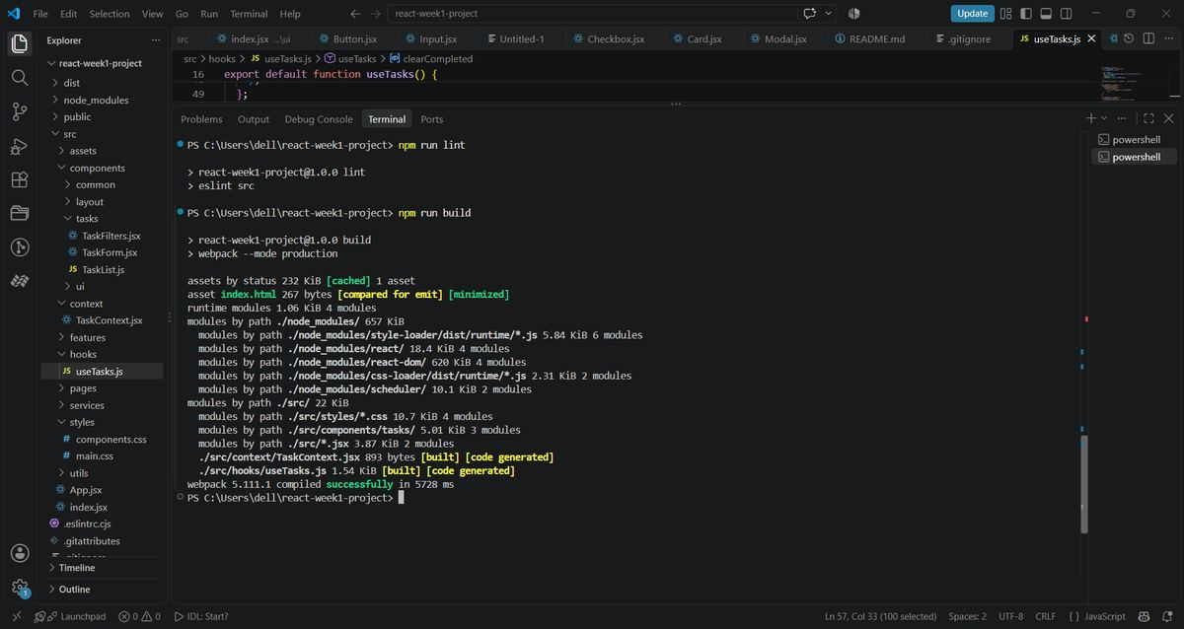

Screenshot 2
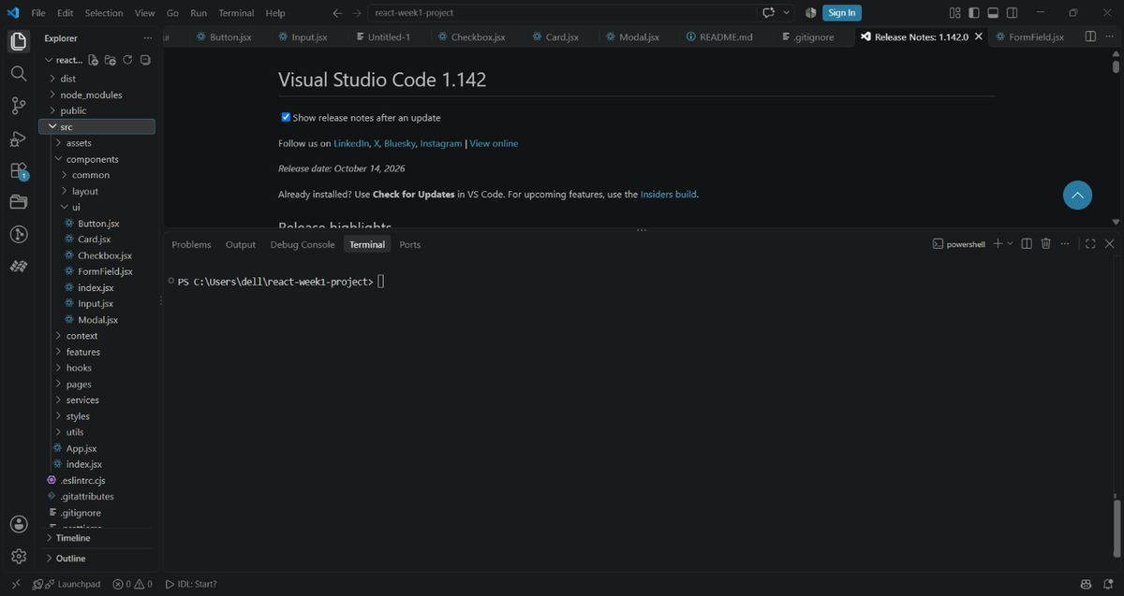

Screenshot 3
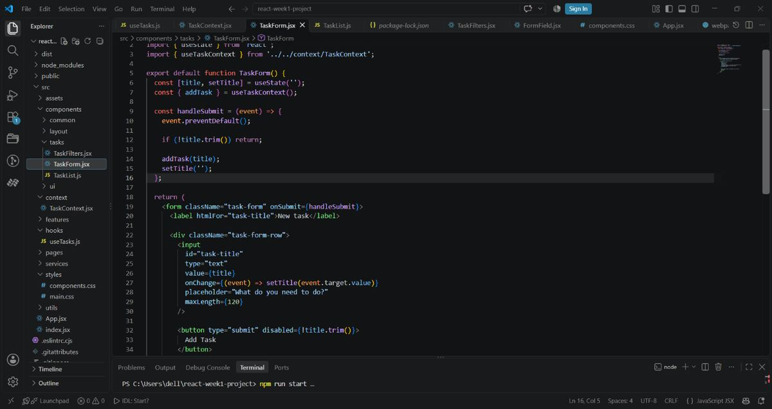

Screenshot 4
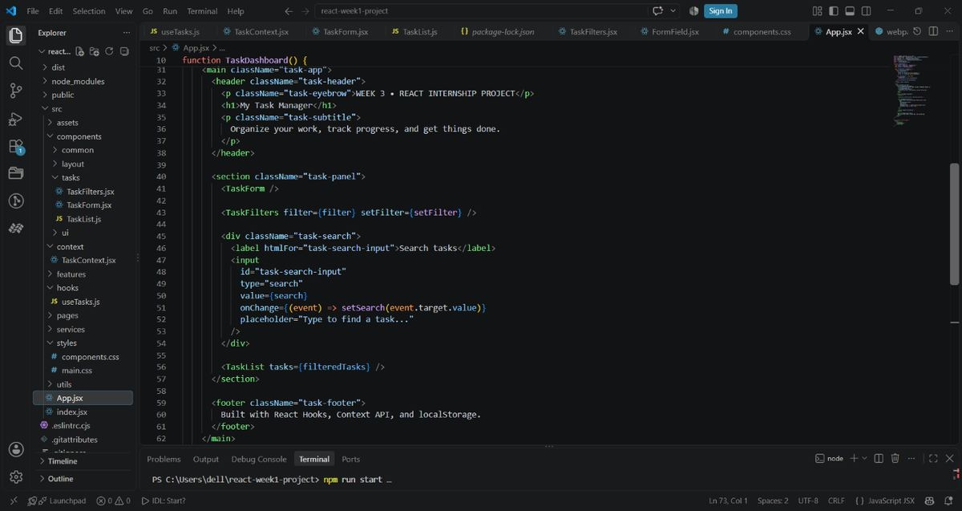

Screenshot 5
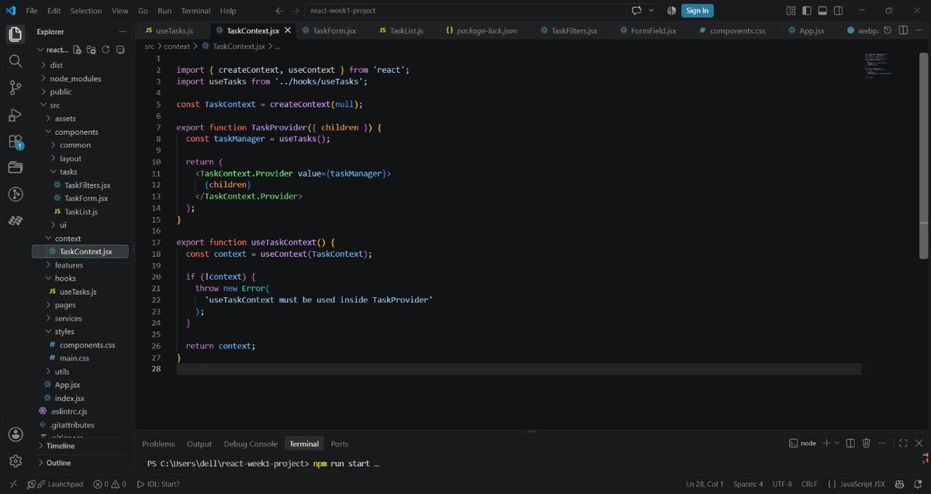

Screenshot 6
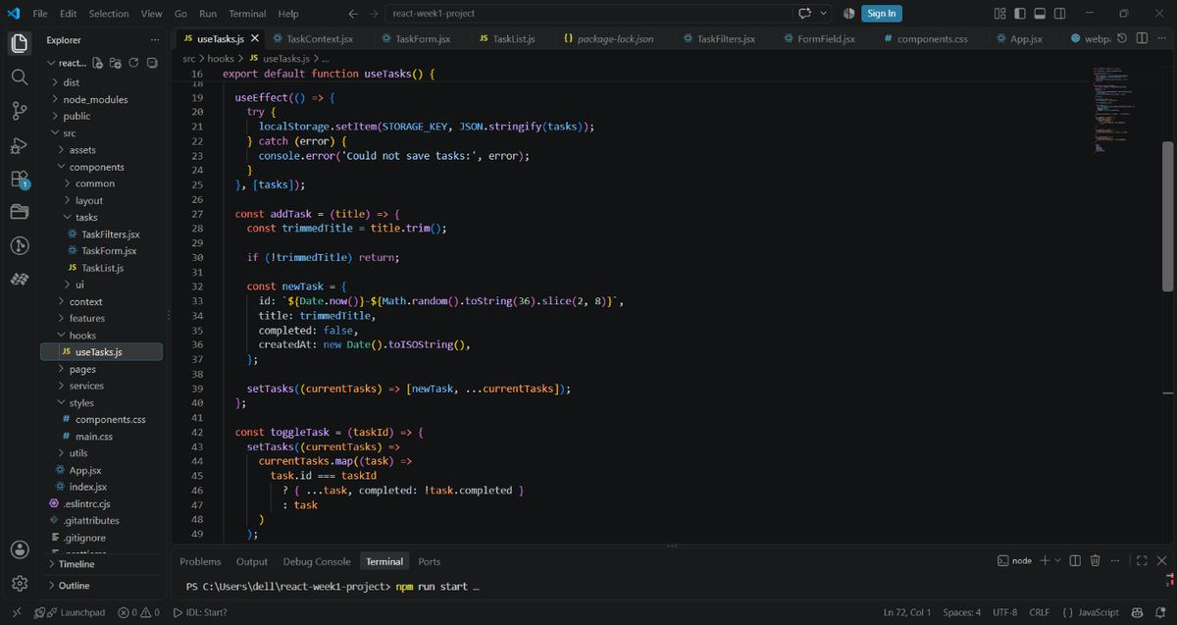

Screenshot 7
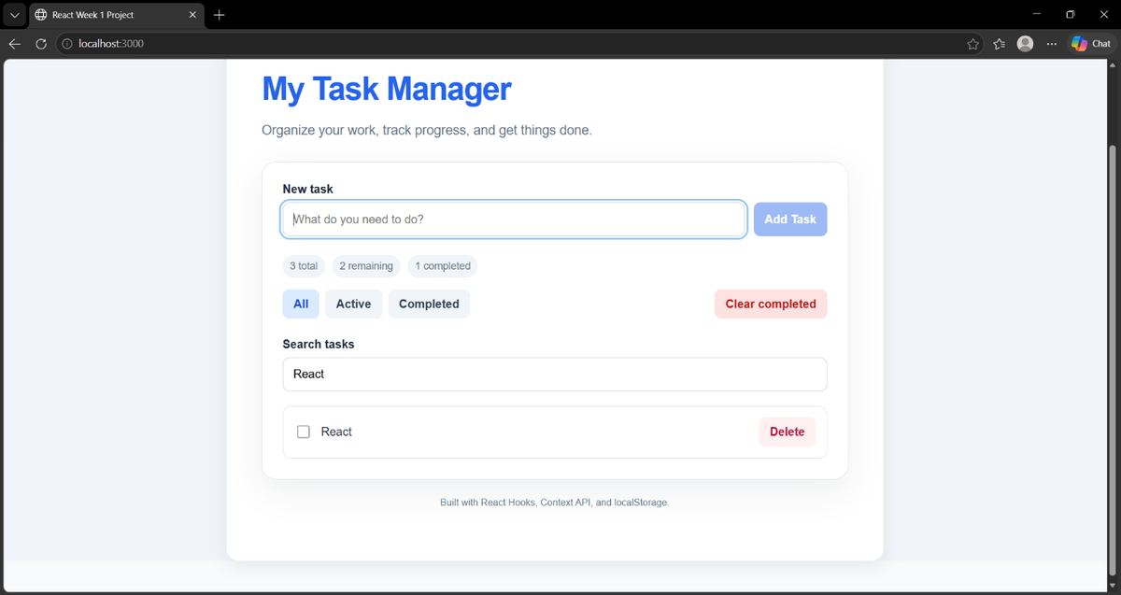

Screenshot 8
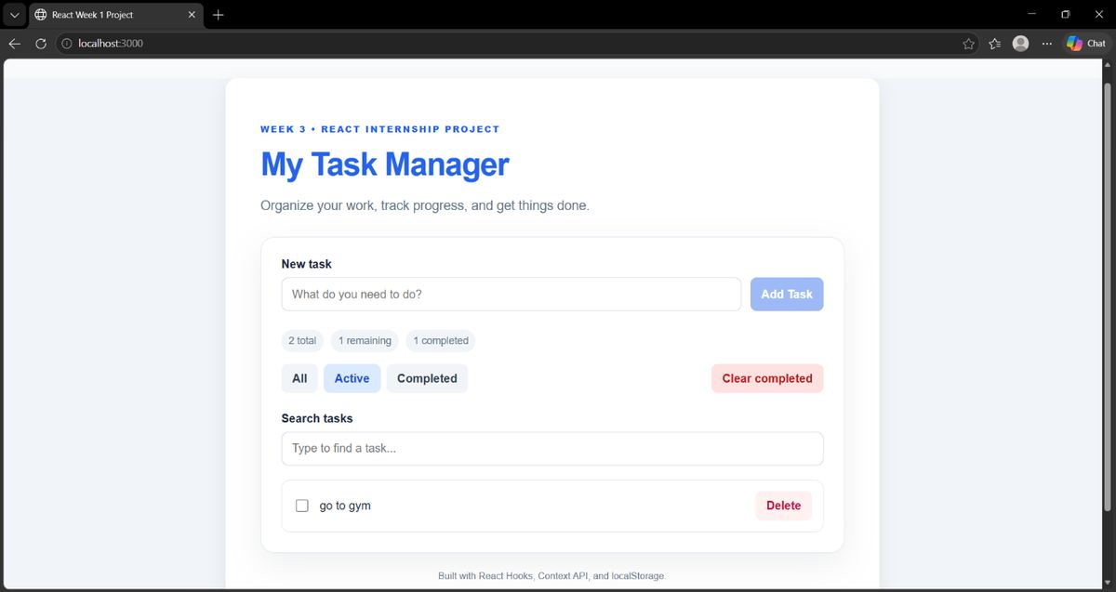

Screenshot 9
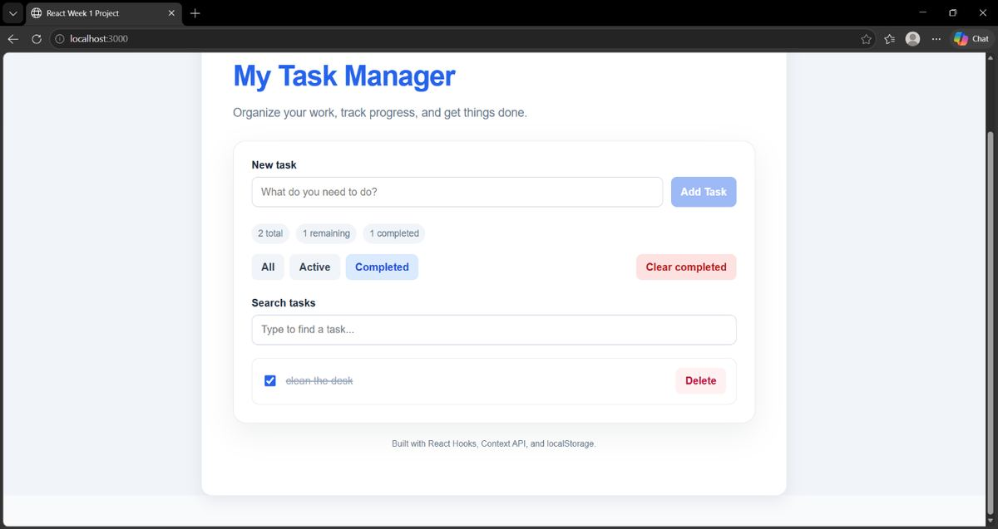

Screenshot 10
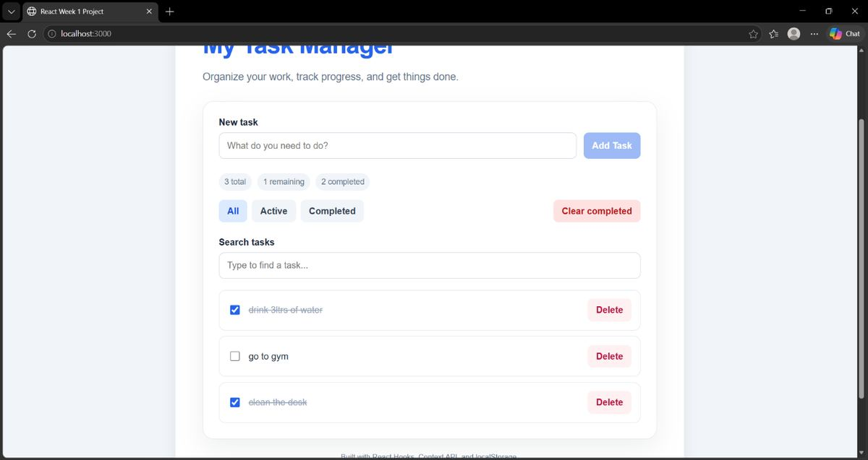

Screenshot 11
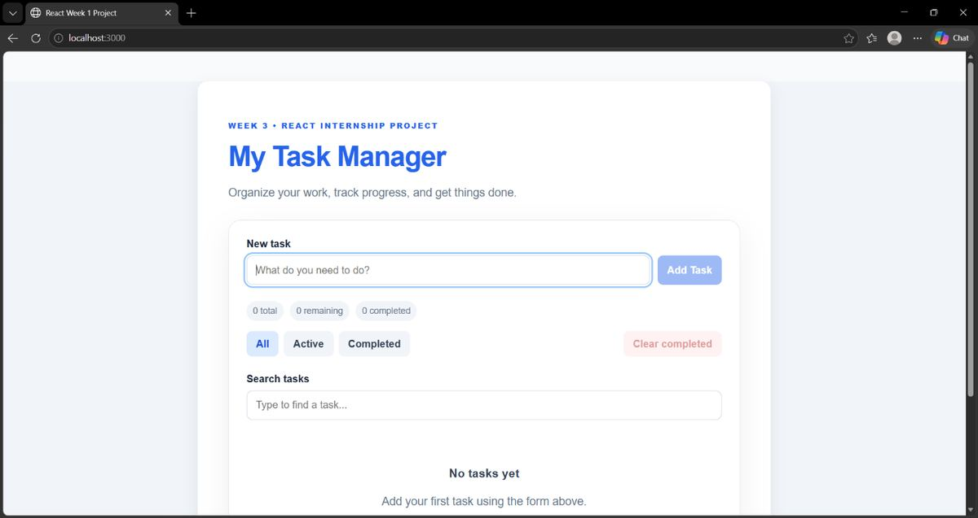

Screenshot 12
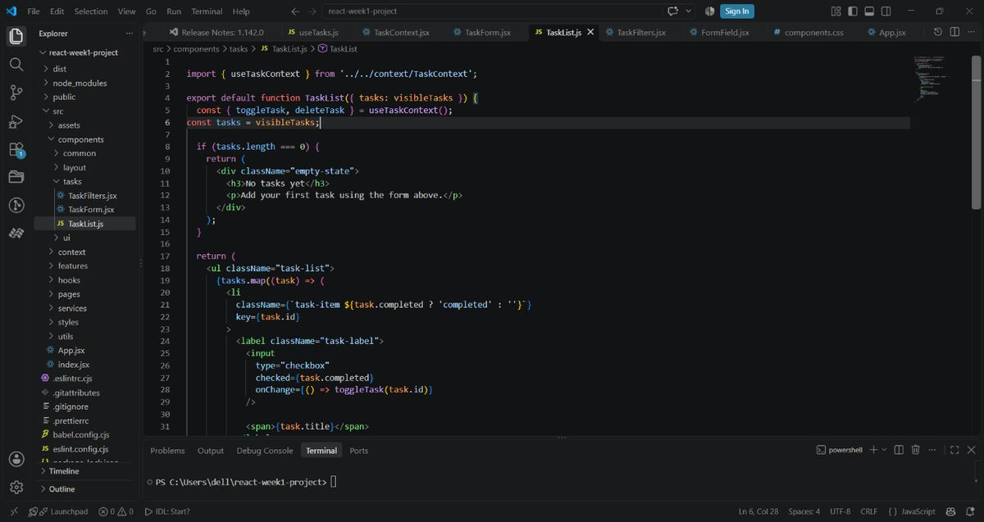

Screenshot 13
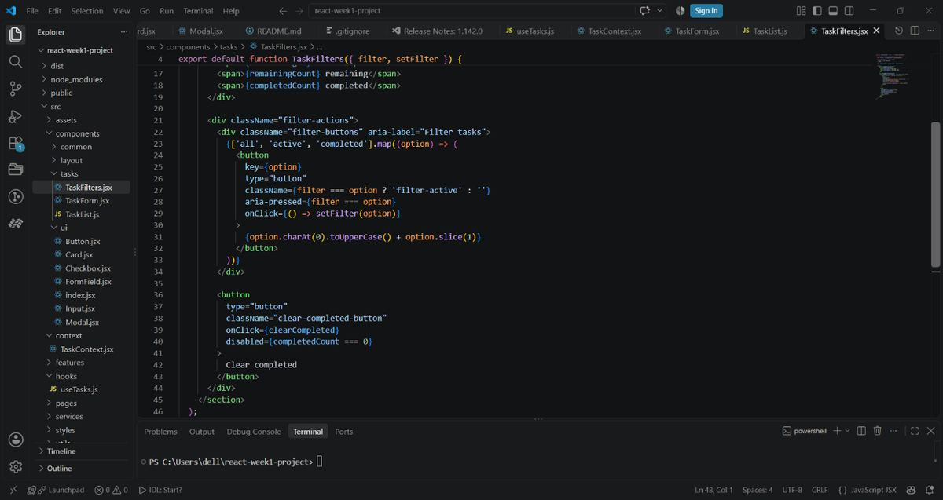

Screenshot 14
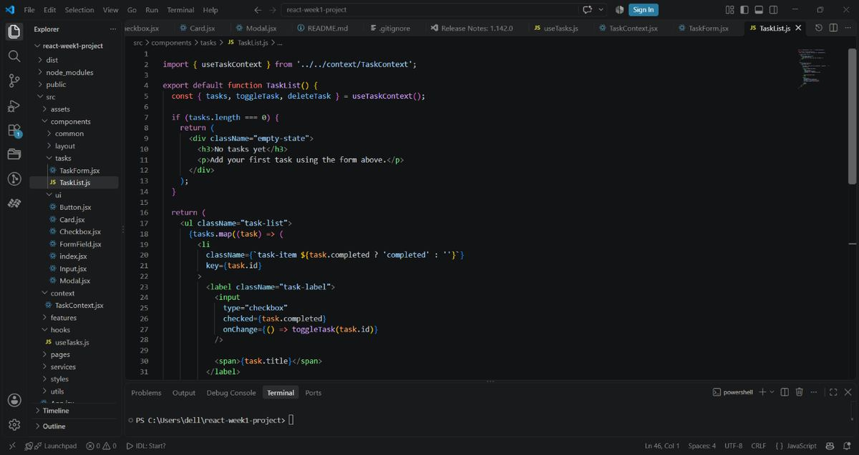

Screenshot 15
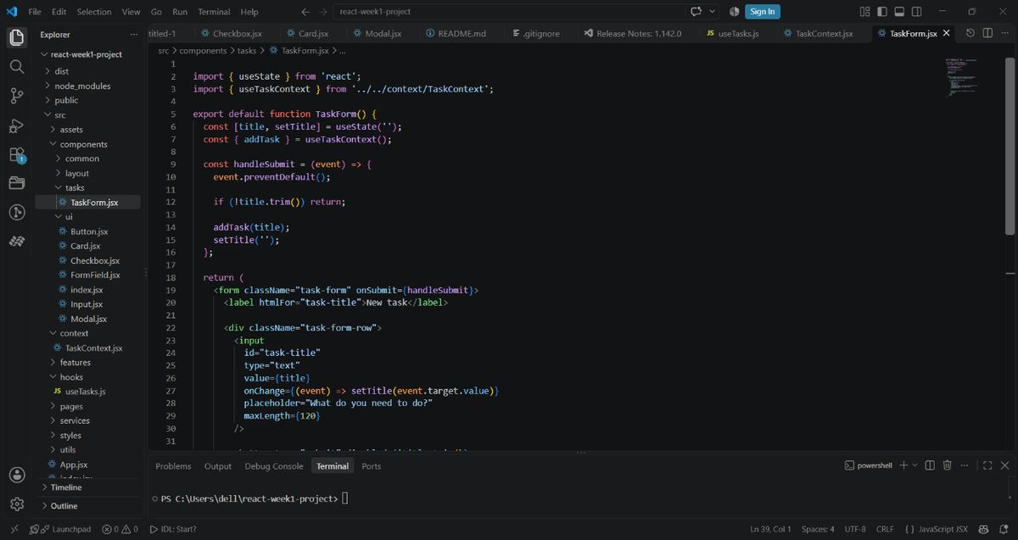

Screenshot 16
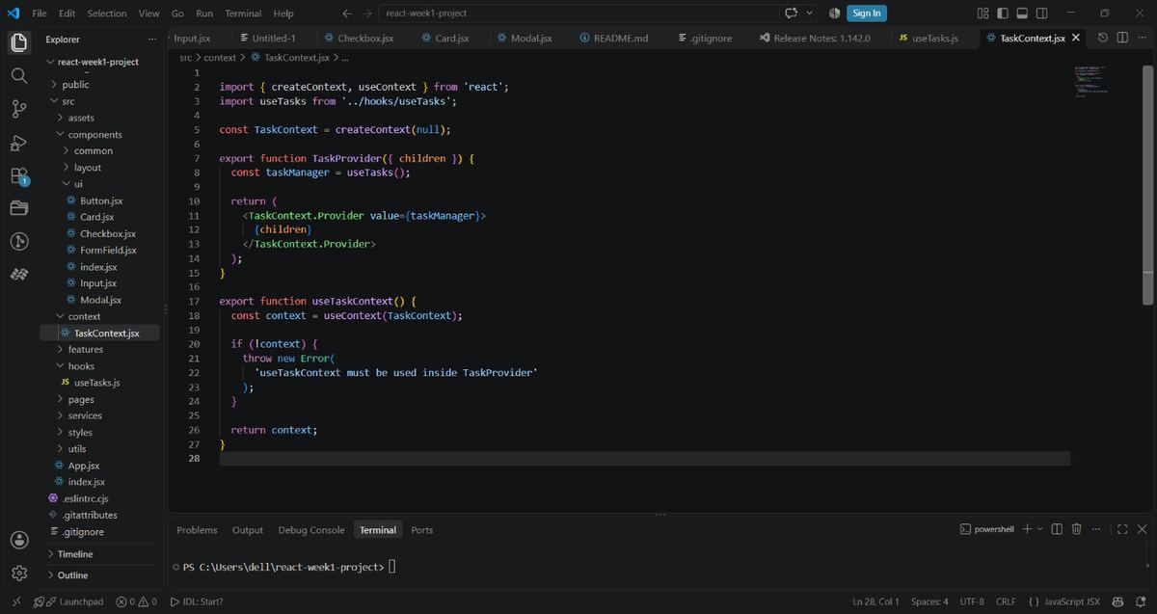

Screenshot 17
